**Road Map to the project (Project Plan & Approach)**

**User Requirement/ User Story (...from user: Matt):**

Create a Social Media Marketing Page for a product: coffee cups or sites to visit in Florida or Silk Saree Pauline

* Have **3-5 feature** like :
* Use **Spring framework** in Java to build the application.
* Create your **database**
* First, create the **application locally**
* Host it in URL next (**host online**). You can use GitHub profile – incorporate **code hosted in GitHub**, GitHub provides application server, and it is easier using GitHub.

**Knowledge Needed:**

* Core Java
* Database Knowledge
* With JDBC/hibernate
* HTML
* Servlet
* JSP
* Java Script
* Spring MVC
* Maven
* GitHub
* Google app/Open Shift

**Features for website**

Refer: <https://blog.hootsuite.com/types-of-social-media/>

<http://www.easymedia.in/7-key-characteristics-of-social-media/>

[https://www.smashingmagazine.com/2009/06/9-crucial-ui-features-of-social-media-and- networking-sites/](https://www.smashingmagazine.com/2009/06/9-crucial-ui-features-of-social-media-and-%20%20%20%20%20networking-sites/)

Facebook Marketing:<https://www.tutorialspoint.com/facebook_marketing_online_training/index.asp>

1. Post pictures/audio/video of the cups/ sarees in the social media page, in real time.
2. Posts have timestamp of the post
3. The audience can follow you and you can follow someone in the social media page
4. Messenger/ Chat window for personalized shopping experience
5. Share the Social media page
6. Email feature
7. Search Engine Feature
8. Consumer Review, Ratings and Feedback
9. Social shopping- Emotion over content
10. Using QR code in your web application.

Objectives: <https://www.searchenginepeople.com/blog/effective-social-media-campaigns.html>

**Different features Expanded**

**1) Homepage for the application Using HTML**

**2) Inserting static image in the webpage using servlet JSP:**

<https://www.youtube.com/watch?v=JJFvsBV2C84>

**CRUD (Create (Insert), Read, Update and Delete)**

**Complete: Insert and Read. For Next: Update and Delete next.**

<https://www.youtube.com/watch?v=GuPAcoyYtPY>

Insert update delete and display data in jtable

[https://www.youtube.com/watch?v=QKsfH...](https://www.youtube.com/watch?v=QKsfHqu4Pps)

[https://www.youtube.com/watch?v=WIMoj...](https://www.youtube.com/watch?v=WIMojkwMTa0)

<https://en.wikipedia.org/wiki/Create,_read,_update_and_delete>

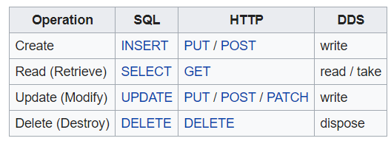

**Connection**

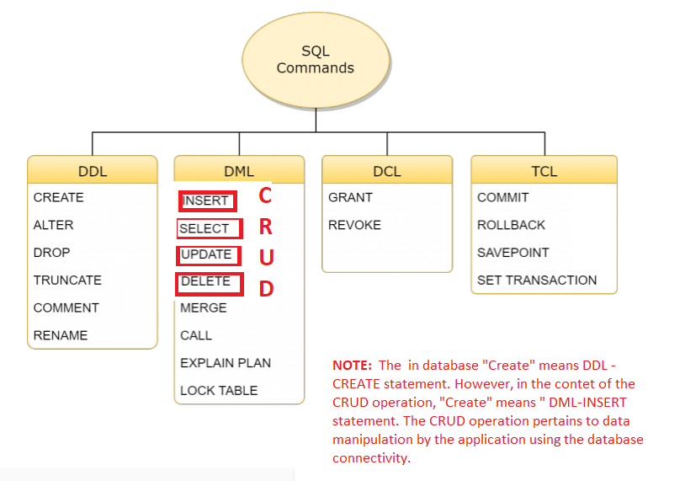

[**https://www.w3schools.in/mysql/ddl-dml-dcl/**](https://www.w3schools.in/mysql/ddl-dml-dcl/)

**Create –Insert Statement**

**3) Inserting text data in the database- Feedback Feature related to Spring MVC: (14:40 onwards)**

<https://www.youtube.com/watch?v=PysTtVcbX4E&index=3&list=PLsyeobzWxl7pYWSoIhLHFKPzEky7DiGoN>

<http://www.ironspider.ca/forms/simpleform.htm>

https://www.youtube.com/playlist?list=PLlB9uPzAE6UFIol39dTjJC3VOOv6xUW6t

The Tulesko guys feedback related html (check the image):

**4) Inserting -Uploading/ storing the image from the webpage dynamically into the database**

Storing the image from the webpage into the database:

<https://www.youtube.com/watch?v=wty6OROO__8&list=PLsyeobzWxl7pUPF2xjjJiG4BKC9x_GY46&index=7&t=115s>

<http://www.codejava.net/coding/upload-files-to-database-servlet-jsp-mysql>

Refer: “Java Tutorials relating to MySQL” videos under database for the project section

<https://stackoverflow.com/questions/26400994/how-to-display-image-from-mysql-database-using-spring-mvc>

<http://www.theserverside.com/discussions/thread/5444.html>

How to store image in a database:

<https://www.youtube.com/watch?v=WWIw_7NuHRo>

<https://www.youtube.com/watch?v=30tYgLU0FLw>

Part-1: <https://www.youtube.com/watch?v=30tYgLU0FLw>

Part-2: https://www.youtube.com/watch?v=8ZJ5ERvmfkU

**How to upload images using servlet/ jsp into MySQL Database:**

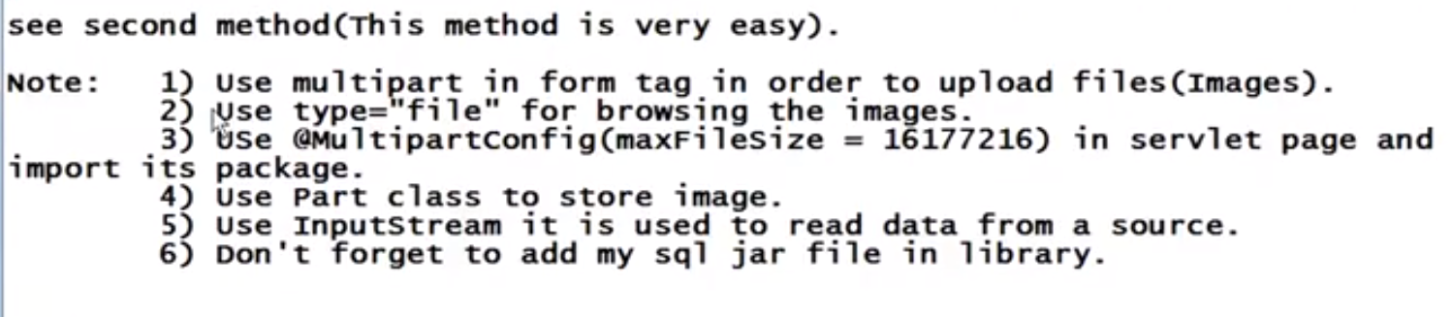

Dharmesh Mourya: <https://www.youtube.com/watch?v=nv_zL7A_Bxg> (Check 6:38 onwards)

<https://www.youtube.com/watch?v=T63VJwkKq1A&t=20s>

image loading-1 : <https://www.youtube.com/watch?v=LoQgu8n925w>

image loading-2 : <https://www.youtube.com/watch?v=yMxTEjHKMNg>

image loading-3: <https://www.youtube.com/watch?v=iFaZafEd9VU>

<https://docs.oracle.com/javaee/6/tutorial/doc/glraq.html>

Upload: <https://www.youtube.com/watch?v=OC9EBXGLL0w>

Upload: <https://www.youtube.com/watch?v=-2SJRCJHzws>

Multipart file in spring boot:

To resolve problem relating to multipart file:

<https://stackoverflow.com/questions/47034878/how-to-pass-multipart-image-file-as-parameter-to-a-post-rest-service>

<http://www.baeldung.com/spring-file-upload> (Check option4)

<http://javasampleapproach.com/java-integration/upload-multipartfile-spring-boot>

<http://www.codejava.net/coding/upload-files-to-database-with-spring-mvc-and-hibernate>

<http://www.technicalkeeda.com/spring-tutorials/insert-image-using-spring-jdbctemplate>

<https://howtodoinjava.com/spring/spring-mvc/spring-mvc-multi-file-upload-example/>

<http://cmk-java.blogspot.com/2014/02/saving-and-retrieving-of-blob-object-in.html>

<https://www.youtube.com/watch?v=4yb16lTxbM8&list=PLsyeobzWxl7oGCz4k9VyxhfmQpSU1dV9b&index=16>

<http://www.java2s.com/Tutorials/Java/java.sql/PreparedStatement/Java_PreparedStatement_setBinaryStream_int_parameterIndex_InputStream_x_.htm>

<http://www.informit.com/articles/article.aspx?p=25280>

<https://gardiary.wordpress.com/2010/04/06/file-upload-and-download-using-spring-mvc/>

**Read (Retrieve)-SELECT Statement**

**5) Read and Validate data: Login feature related to Spring MVC- to validate username and pwd.**

<https://dzone.com/articles/spring-mvc-example-for-user-registration-and-login-1>

[http://www.studentstutorial.com/java-project/password-change-in-jsp.php#](http://www.studentstutorial.com/java-project/password-change-in-jsp.php)

<https://dzone.com/articles/spring-mvc-example-for-user-registration-and-login-1>

<https://www.youtube.com/playlist?list=PLlB9uPzAE6UFPVgiSb9slJ8hhpQ28OG4->

http://www.jcombat.com/spring/spring-mvc-based-login-application

**6) Reading and Retrieving all Image dynamically from the database** <https://www.youtube.com/watch?v=ppzYGd0wi_c>

**7) Searching and retrieving selected Images dynamically from the database**

Using the Search engine to display the searched items from the database in webpage

Html for search engine: (check the comment section for the code)

<https://www.youtube.com/watch?v=wtVwMgl80WU>

Showing the HTML page: <https://www.youtube.com/watch?v=38rJPEqapoA>

<https://www.youtube.com/watch?v=xTz_yAAgR24>

Videos: 34, 35, And 36 in the playlist: <https://www.youtube.com/playlist?list=PL27BCE863B6A864E3>

<https://www.youtube.com/watch?v=-ekqLViEvHg>

<https://www.youtube.com/watch?v=anoPsxasIBE>

SEARCH : <https://www.youtube.com/watch?v=uuhEb0k3vVE>

<https://www.youtube.com/watch?v=uuhEb0k3vVE>

<https://www.youtube.com/watch?v=MY4FavUyFNQ>

<https://www.youtube.com/watch?v=bLZXJTAcu5I>

Search using dropdown list:

<https://www.youtube.com/watch?v=CkdzDeegwjY>

<https://www.youtube.com/watch?v=BzTdI7OgYjA>

Radio button related

<https://www.daniweb.com/programming/web-development/threads/369571/accessing-the-radiobutton-value-inside-the-table-element-of-html>

To get the value from the radio button and store it in a variable:

<https://stackoverflow.com/questions/21746094/how-can-i-get-the-selected-radio-button-value-on-another-jsp-page>

**8. Using Java Filter option: (Select and where condition) –Price Filter**

FILTER: <https://www.youtube.com/watch?v=TfuC_bxwr3w>

<https://www.ibm.com/support/knowledgecenter/en/SSKTXQ_9.0.0/admin/config/config_chat_ldap_java_people.html>

<https://stackoverflow.com/questions/6839773/how-to-construct-search-filter-for-a-java-ldap-search-api-when-object-name-has>

<http://www.java2s.com/Code/Java/JNDI-LDAP/SearchingtheDirectorybyUsingaSearchFilter.htm>

<https://www.mkyong.com/java8/java-8-filter-a-map-examples/>

How To Filter Data From MySQL And Show It In JTable

[https://www.youtube.com/watch?v=TfuC_...](https://www.youtube.com/watch?v=TfuC_bxwr3w) [https://www.youtube.com/watch?v=i9_Kx...](https://www.youtube.com/watch?v=i9_Kx_79RWo)

**Update (Modify)-UPDATE Statement**

**9. Update data in database related:**

<https://www.youtube.com/watch?v=1nlrQy2P3bk&index=22&list=PLoLtuXR_wgvMkoFiU-X6Tbajr-LdUuoOK>

<https://www.youtube.com/watch?v=HODTNRBdyxM&list=PLd3UqWTnYXOniKfYRNY___weULTRd9Co0&index=51>

**Delete (Destroy)-DELETE Statement**

**10. Deleting the image stored in the database dynamically from the webpage**

Delete Data in MySQL Database Using Java

[https://www.youtube.com/watch?v=uKEgK...](https://www.youtube.com/watch?v=uKEgKETRCzE)

**Other Features: For Next Version:**

(Check GontuSeries: Spring MVC (46 video) for web application under Spring Framework for website to get some more features.)

Also check: Functionality related to Facebook: Building Web Application Using Spring Framework

(17:00 onwards)Edureka: <https://www.youtube.com/watch?v=tfMRF_cDgDw>

**11. Using QR code in the web application:**

<https://www.youtube.com/watch?v=yFpkdkibvfg&index=116&list=PLsyeobzWxl7oZ-fxDYkOToURHhMuWD1BK>

[Refer code.docx for the html related to QR code](code.docx)

**12) Loading excel file into database using jsp:**

<https://stackoverflow.com/questions/24278477/insert-excel-data-to-database>

<https://www.roseindia.net/tutorial/java/poi/insertExcelFileData.html>

**13) How to insert data and time in MySQL using Java:**

<https://www.thecrazyprogrammer.com/2016/02/how-to-insert-date-and-time-in-mysql-using-java.html>

<https://www.thecrazyprogrammer.com/2015/12/get-last-inserted-record-id-in-mysql-using-java.html>

**14) Adding Music to the website**

<https://alvinalexander.com/java/java-audio-example-java-au-play-sound>

**15) Share the website in the Social Media**

## Spring E-mail Support:

## <https://www.javacodegeeks.com/tutorials/java-tutorials/enterprise-java-tutorials/spring-tutorials/>

Spring provides MailSender to send email via JavaMail API. This section also provides tutorials on how to integrate Spring with third party mail providers and their APIs.

* [Sending e-mails in Java with Spring – GMail SMTP server example](http://www.javacodegeeks.com/2010/07/java-mail-spring-gmail-smtp.html)
* [Spring, Quartz and JavaMail Integration Tutorial](http://www.javacodegeeks.com/2011/06/spring-quartz-javamail-tutorial.html)
* [Spring E-Mail Support – GMail SMTP Server Example](http://examples.javacodegeeks.com/enterprise-java/spring/mail-spring/spring-e-mail-support-gmail-smtp-server-example/)
* [How to compose html emails in Java with Spring and Velocity](http://www.javacodegeeks.com/2014/07/how-to-compose-html-emails-in-java-with-spring-and-velocity.html)

**16) Multiple languages (internalization) feature related Spring MVC:**

<https://o7planning.org/en/11227/create-a-multiple-languages-web-application-with-spring-mvc>

<https://www.youtube.com/playlist?list=PLYZvWFacASF9uG9gHDEGTM5XxnvCRJAL7>

<https://www.youtube.com/watch?v=M8bap7ap_UI>

Research on ApplicationContext

**17) Creating Chat Window feature:**

**18) Create Product Wish list/Shopping Cart:**

**Spring Framework for website**

**When to learn spring framework?** (Prerequisite): <https://www.youtube.com/watch?v=qODaFAT6at0>

**What are Java Frameworks?**

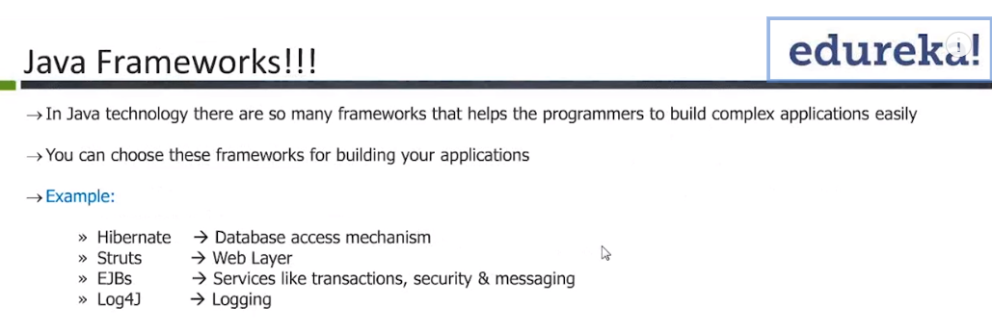

Java Frameworks: E.g.: Struts (old framework used for web technology), Hibernate ( is also a little old when a lot of database is used). Hibernate – ORM (Object Relational Mapping) Database can talk directly to POJOs (Plain Old Java Objects- A class with some attributes associated with either constructors or setter and getter methods it will not extend or impalement any of the framework relate classes or interfaces) rather than underlying relations , Database related. Spring ( a new and popular framework for creating live websites), Hibernate and Spring are the popular in the market. EJBs is outdated. Log4J used for logging

**Why spring?**

Spring is the de-facto standard for enterprise level application. Spring includes other framework like hibernate and integrates other technology like Mango DB, Hadoop, Big Data etc. , which is not done by struts. So, spring is seen as “framework of Frameworks”

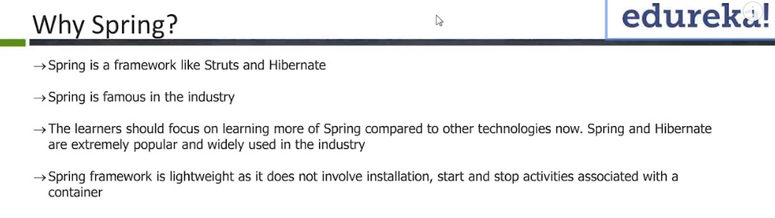

**What are the Spring Frame work Variations and what knowledge is needed to use it?**

1. Spring core – Needed: Knowledge on core java until exception handling, threads, collection.
2. **Spring MVC** – Needed: Knowledge on Servlet, jsp, Tomcat(host Sever to host website)
3. **Spring Rest** – Needed: Rest API
4. Spring boot –Easy to use, can be attempted without knowledge on core java, advantage is it helps in configuration management

( Check article and at the end 24 videos on spring boot: <http://www.springboottutorial.com/spring-boot-vs-spring-mvc-vs-spring> )

1. Spring ORM

6. Spring Rest:

**Difference between Spring Rest vs Spring MVC:**

<https://www.quora.com/What-is-the-difference-between-normal-Spring-MVC-and-Spring-RESTful-web-service>

**Note:** Understand what 1-6 means, also understand about Maven

**What is maven, why it is required to build Spring projects?**

<https://www.quora.com/What-is-Maven-in-Java-Why-is-it-required-to-develop-Spring-MVC-application-Is-it-possible-to-create-Spring-MVC-application-without-Maven>

**What Spring Offers?**

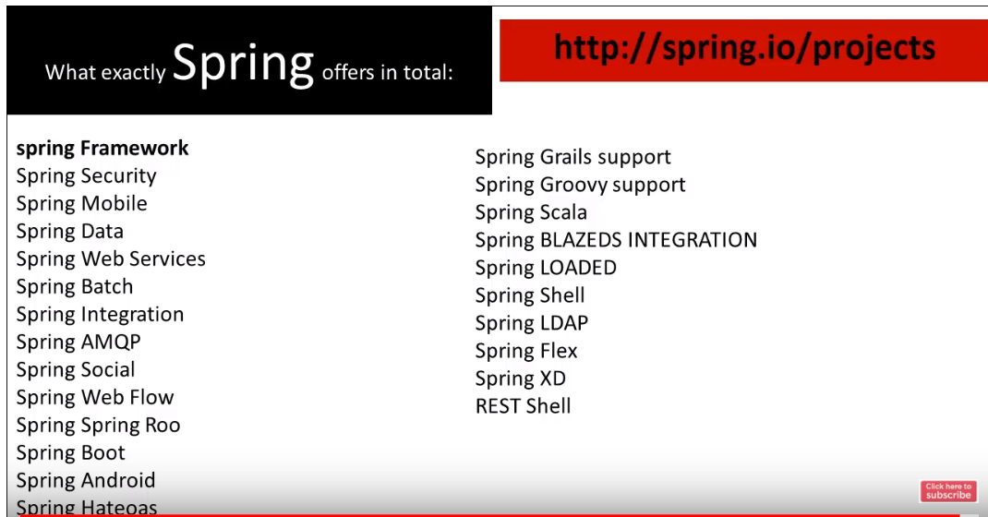

**What are the modules of Spring Framework?**

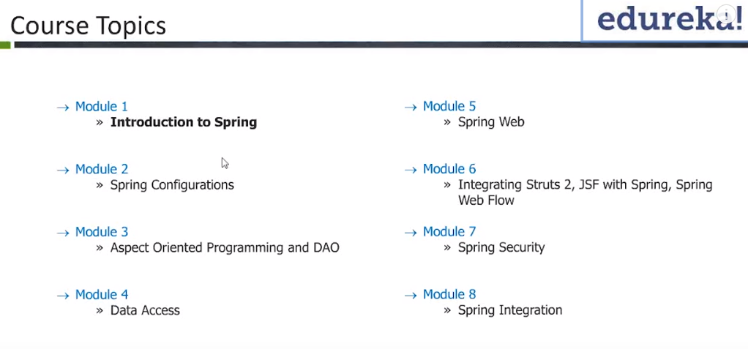

**Tutorials Related to spring and its various versions:**

**To order the concepts related to spring use this:**

Tutorials Point: <https://www.tutorialspoint.com/spring/spring_overview.htm>

**Spring Framework**

Some Free Videos the best entire list of videos **Important:**

<https://www.udemy.com/javaspring/>

Spring Framework by Java Brains (24 videos)

<https://www.youtube.com/playlist?list=PLC97BDEFDCDD169D7>

Spring Framework tutorial- Java-9s: (9videos)

<https://www.youtube.com/playlist?list=PL2882729612B70122>

Spring Framework tutorial- in28Mins: (32videos)

<https://www.youtube.com/playlist?list=PLBBog2r6uMCRglPLPFqxz5pzdE3ApR0Yt>

Spring Framework **Important- Basic idea of Spring Framework (see from video-17) GontuSeries**

<https://www.youtube.com/playlist?list=PLBgMUB7xGcO1YY1J9NoXssmaB0FjLSbQ5>

Edureka: 1-13 videos

<https://www.youtube.com/playlist?list=PL9ooVrP1hQOEfi91PCFQMawtBJrPpir7y>

Spring Framework interview video:

<https://www.youtube.com/watch?v=2prdt2byiTs>

Check : [Spring Playlist](../TutorialNotes/Spring%20Playlist.docx)

**Spring Framework with Maven:**

Spring Framework with Maven Tutorial (13 videos) -**Theory**

<https://www.youtube.com/playlist?list=PLsyeobzWxl7rFkYFysfTwBu1JBPaNNDrk>

<https://www.javatpoint.com/maven-tutorial>

<https://www.youtube.com/watch?time_continue=2&v=0CFWeVgzsqY>

**Spring MVC:**

Use this to arrange the topics related to Spring MVC tutorials

<https://o7planning.org/en/10959/spring-mvc>

Spring MVC tutorial for Beginners (11 videos) -**Examples**

<https://www.youtube.com/watch?v=BkRZfxznaOo&list=PLsyeobzWxl7rjSO6xX00UWmVhL90i-cOk>

Java Web Development Spring MVC | AWS (9 video)

<https://www.youtube.com/playlist?list=PLsyeobzWxl7pKG5WQqzVfqExq6DEWKOZl>

Live project using Spring MVC on AWS: (10 videos) – **Important -Hands-on**

<https://www.youtube.com/playlist?list=PLsyeobzWxl7pYWSoIhLHFKPzEky7DiGoN>

**GontuSeries:** Spring MVC (46 video) for web application: **Important:**

<https://www.youtube.com/playlist?list=PLBgMUB7xGcO31B2gBmy1igpZn6LK78-CJ>

**Spring Rest:**

Recommended knowledge for Spring Rest: **Rest API and Restful Web Services**

<https://www.youtube.com/playlist?list=PLsyeobzWxl7ps4Z1C4VMtvZEx5-PgyoYI>

**Core Java:**

[Follow the tutorial links in Java Links Modified that you created](../TutorialNotes/Links%20JAVA%20modified.docx)

**Database for website**

**Option-1 :JDBC**

[In Java Links Modified Tulesko learnings: 7 –Videos: 16.1 to 16.7](../TutorialNotes/Links%20JAVA%20modified.docx)

Java JDBC Durgasoft (the best interesting)- (189 videos):

<https://www.youtube.com/playlist?list=PLd3UqWTnYXOnRmJm3Q5eZODL0Dyt6cM5a>

JDBC Interview playlist-Durgasoft: (10 videos)

<https://www.youtube.com/playlist?list=PLd3UqWTnYXOm8DK2z3fvnFsfPrPmliRHh>

USE: Java Database connectivity –JDBC (8 videos)

<https://www.youtube.com/playlist?list=PLsyeobzWxl7rU7Jz3zDRpqB-EODzBbHOI>

(OR)

**Option-2: Hibernate:** (27 videos)

<https://www.youtube.com/playlist?list=PLsyeobzWxl7qBZtsEvp_n2A7sJs2MpF3r>

Hibernate: Patrick Washington 18 step by step videos:

<https://www.youtube.com/playlist?list=PL5745BA630E2195D9>

<https://www.javatpoint.com/hibernate-tutorial>

<https://www.tutorialspoint.com/hibernate/index.htm>

**Database used: MYSQL:**

MySQL: <https://www.youtube.com/playlist?list=PLGwb7xZHg-oOA90-RyVQYYDFc1PO2xb1k>

34 videos on MySQL: <https://www.youtube.com/playlist?list=PLlB9uPzAE6UFruhc3s8wgFfZjxJ6IrGhv>

**Deploying the Code & hosting it online:**

**Hosting the website locally**

<https://www.youtube.com/watch?v=dsW8KDubzos>

https://www.youtube.com/watch?v=ohkMRA74MB4

https://www.youtube.com/watch?v=jnf0bwbenDE

**Hosting the website Online**

**Option-1 Google app engine option- free for 12 months (requires credit card information)**

(At 44:46 Live Project Session-4 onwards)

**GitHub Tutorial for beginners: (8 videos)**

<https://www.youtube.com/watch?v=OdbBmvfThJY&list=PLsyeobzWxl7q2eaUkorLZExfd7qko9sZC>

Also refer to Spring MVC tutorial for Beginners (11 videos) to learn about GitHub open shift server.

Open Shift Java WebApp deployment tutorial: (6 video)

<https://www.youtube.com/watch?v=WURaFVPwBHQ&list=PLsyeobzWxl7rpmHJD_u8s6yVnxNaxzw3W>

**HTML** Crash Course for Absolute Beginners:

<https://www.youtube.com/playlist?list=PLillGF-RfqbZTASqIqdvm1R5mLrQq79CU>

HTML: <https://www.w3schools.com/html/default.asp>

CSS: <https://www.w3schools.com/css/default.asp>

(Defining multiple elements in style: <https://www.w3schools.com/html/html_css.asp>

<https://www.w3schools.com/html/tryit.asp?filename=tryhtml_table_intro>

Table styling trick (for referring to formatting a particular row or particular column):

<https://css-tricks.com/complete-guide-table-element/>

<https://www.w3schools.com/tags/tryit.asp?filename=tryhtml_col_test>

<https://www.w3schools.com/css/tryit.asp?filename=trycss_table_fancy>

**JSP (Vs) JavaScript (Vs) Servlet:**

https://www.quora.com/What-is-the-difference-between-JavaScript-servlet-and-JSP

**Java Script:** <https://www.w3schools.com/js/default.asp>

Java Script video tutorial <https://www.tutorialspoint.com/javascript_online_training/index.asp>

**Servlet**

Servlet & JSP for beginners:

**Java Servlet and JSP tutorial (25 Videos)**

<https://www.youtube.com/playlist?list=PLsyeobzWxl7oGCz4k9VyxhfmQpSU1dV9b>

Videos- <https://www.youtube.com/playlist?list=PLsyeobzWxl7pUPF2xjjJiG4BKC9x_GY46>

<https://o7planning.org/en/10979/java-servlet-jsp>

Servlet:

<https://www.youtube.com/playlist?list=PLGwb7xZHg-oN26skOGaoo8evquJ9VXI47>

<https://www.tutorialspoint.com/java_servlet_online_training/index.asp>

**JSP- Java Server Page:**

<https://www.tutorialspoint.com/jsp/jsp_overview.htm>

<https://www.javatpoint.com/jsp-tutorial>

<https://www.guru99.com/jsp-tutorial.html>

<https://www.youtube.com/playlist?list=PLFRwE3zKgyLUcEOGjjn_xFQUAjJOoPDsW>

Home.jsp: <https://www.w3schools.com/css/tryit.asp?filename=trycss_navbar_horizontal_black_right>

**Scope for improvement**

**Code Optimization:**

Put the database connection related URL, uname =root, pwd info in a properties file and reuse it

<https://www.youtube.com/watch?v=w7D5YB2U2jU&index=118&list=PLsyeobzWxl7oZ-fxDYkOToURHhMuWD1BK&t=286s>

**Properties file**

**Data Pooling**

**Add More features**

**Cleaning Code:** when I review my code, I will be able to see it in a different perspective and it will help me think about why I did it? And how I can do it differently?

**Using Junit for testing**